# Ex.No-2 AIM:

**PANDAS**

To analyse and study the best performance point of Reciprocating pumps using Pandas.

# PROCEDURE :

1. Dataset Creation:

Create a hypothetical dataset containing information about actual discharge(m3/s), input power(W), and output power(W).

1. Correlation Analysis :

Calculate the correlation matrix to examine the relationships between actual Discharge, input power, and output power using pandas’’corr()’ function.

1. Efficiency calculation :

Calculate the efficiency for each input value using the given formula: Efficiency(%)

= Output_power/Input_power *100

1. Head calculation:

Calculate the total head for each performance using the given formula : Head (m) = output_power/actual discharge *ρg

1. Best Efficiency Point (BEP) :

Identify the Best Efficiency Point of the reciprocating pump from

the efficiency by selecting the highest index values using the pandas’ ‘nlargest()’ function

# PROGRAM:

import pandas as pd data={

'Actual Discharge':[40,50,60,70,80,90], 'Input Power':[1,2,3,4,5,10],

'Output Power':[70,30,90,100,140,170]

}

density=1000 gravity=9.81 a=pd.DataFrame(data)

a['Efficiency']=(a['Output Power']/a['Input Power'])*100

a['Head']=(a['Output Power']/a['Actual Discharge'])/(density*gravity) corr_matrix=a.corr() print(corr_matrix)

max_efficiency=corr_matrix['Efficiency'].nlargest(2).iloc[1]

print("\nParameter with the highest correlation with efficiency=",max_efficiency)

# OUTPUT:

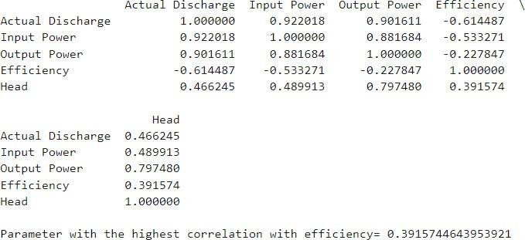

**Result:**

The programs were run successfully